

**HealthTrust Europe LLP: ITT to establish a framework agreement for consultancy solutions and advisory services Contract Notice (FTS) Ref: 2023-041574**

**Technical Response - A1_Implementation_Ethical Healthcare Consulting**

Implementation 10%

A1: Please detail the different stages of the implementation phase you would follow when awarded a contract under the Framework Agreement. This should include as a minimum:

• scoping the requirements, to include how to determine the resources that will be supplied;

• how initial communication is conducted; this should include risk and relationship management and who is responsible;

• how reporting and managing of the call off contract will be undertaken; and

• managing staff recruitment and selection processes

**EHC Response:**

Dependent on the project characteristics, associated risk and complexity different project management approaches, methods and disciplines would be adopted. For example, large, complex, high-risk projects may afford a structured and formal project management approach, whilst other more responsive and innovative projects might benefit from a more flexible and agile approach allowing for iterative design, experimentation, learning and adaption.

EHC Delivery Managers are given guidance through a playbook which provides a framework to best practice and EHC processes. This is provided within our supporting documents **‘*SD19 Delivery Manager Playbook*’.**

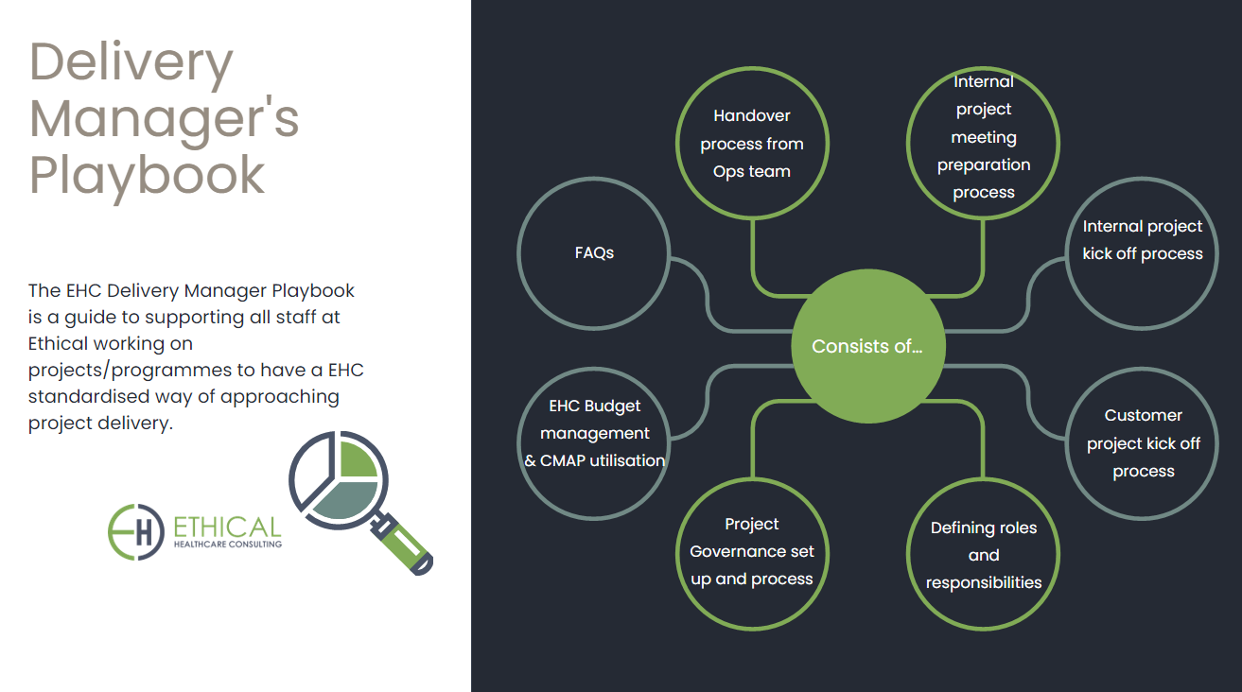

**• scoping the requirements, to include how to determine the resources that will be supplied**

The EHC delivery methodology enables a transparent way of working with clients. Dependent on the type of project, at the Project Initiation Stage or if using an Agile Methodology at the Discovery start, we would look to meet with stakeholders to;

1. Define the problem statements
2. Develop persona’s
3. Undertake journey mapping
4. Develop an in-depth understanding of user needs
5. Collect any relevant documentation
6. Understand market dynamics

This initial engagement helps establish the project objectives and parameters, gain an appreciation of complexity and risk, whilst allowing us to determine capability needed to fulfil delivery. Requirement gathering techniques include; surveys, use case scenarios, ethnographic or user research, mind mapping or prototyping. Delivery Managers would be assigned to the project to support stakeholders and oversee the process. At the end of this phase all relevant information would be gathered and synthesised to help establish with stakeholders the challenges, opportunities, priorities, risks, assumptions and required resourcing.

In response to determining the resources EHC will supply, we utilise a skills matrix which is recorded in our CMAP Project and Management Software to map our peoples’ skills, experience, certifications, and qualifications, and where they may have delivered similar projects elsewhere. This framework helps us select the appropriate capability to match project requirements. EHC have a strict on boarding process and ensure our resources understand the EHC methodologies and completed the necessary training.

**• how initial communication is conducted, this should include risk and relationship management and who is responsible;**

Open communication is key to building productive relationships with our clients. Delivery Managers are assigned to each project who oversee and lead client projects, manage client relationships, coordinate project teams, mitigate risks, and ensure project success. They are supported by a Client Principal that is responsible for ensuring expectations and needs are being met and managed throughout delivery. Communication vehicles will include a mix of either face-to-face meetings or virtual meetings;

1. Regular weekly client meetings with engagement managers and the client principal.
2. Highlight Reports are produced to show progress against projects
3. Project and Programme meetings
4. Risk and Assumptions meeting and development of the Risk Register by the Delivery Manager
5. Change control meetings

Initial communication will involve ensuring the client is happy to approve the project approach and initiation recommendations, agreeing the required capability and resource plan and budget. This would also include establishing project governance, escalation points, client roles and responsibilities, by the Delivery Manager at EHC.

The following slide is taken from the EHC Delivery Manager Playbook, within our supporting documents **‘*SD19 Delivery Manager Playbook*’.**

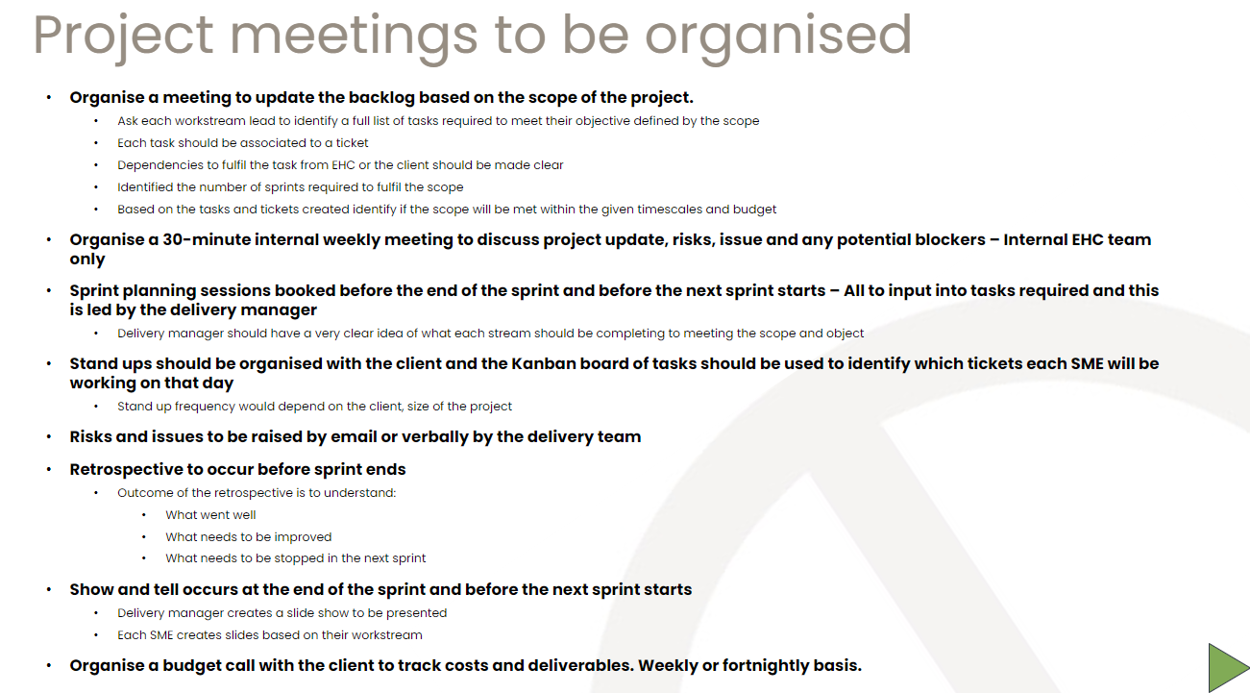

**• how reporting and managing of the call off contract will be undertaken; and**

Keeping our clients and stakeholders informed and managing their expectations is key. Each project is assigned an account Engagement Manager that ensures any conflicts, or risks are managed and there is a consistent understanding of the project’s goals, scope, progress, and outcomes. Regular engagement sessions are scheduled with the client to keep track of the project.

Tracking everything related to the project, such as time, budget, resources, tasks, milestones, risks, issues, and quality can be done via a monthly highlight report that then informs the project or programme board(s) or other related project governance. This can help to monitor the project’s performance, identify potential problems, and take corrective actions as needed.

We utilise a proven Project Management Office (PMO)/ Project Methodologies and processes that that guides us through each stage of the project, from assessment to implementation to evaluation. This assists in providing a clear structure and direction for the project, as well to measure and demonstrate its results.

The following slide is taken from the EHC Delivery Manager Playbook, within our supporting documents **‘*SD19 Delivery Manager Playbook*’.**

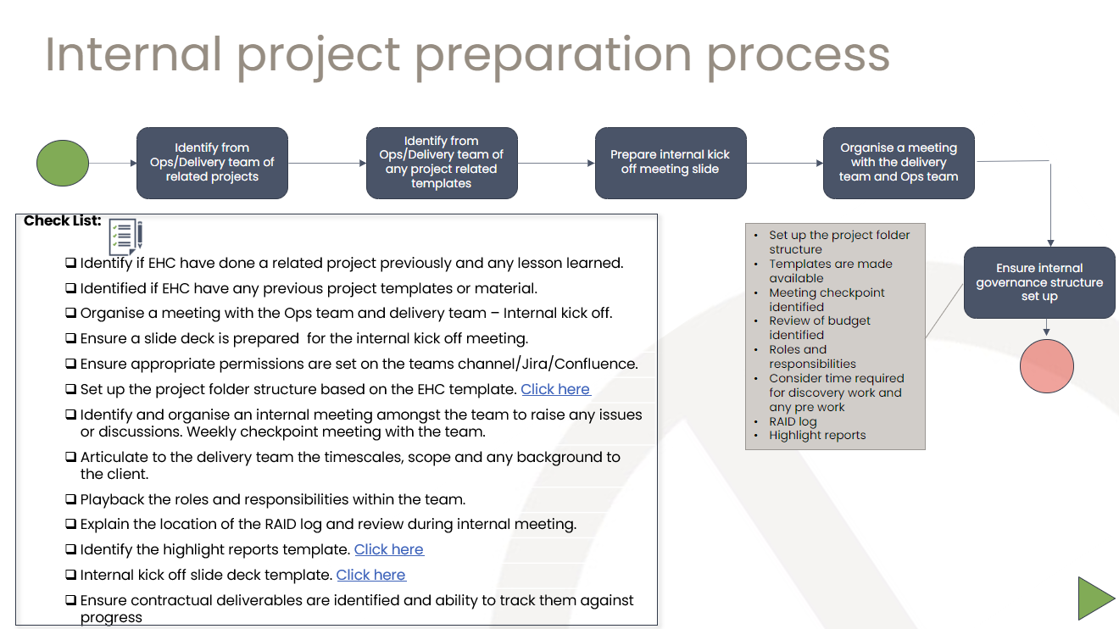

**• managing staff recruitment and selection processes**

We are very proud of the cadre of capabilities we have at EHC. This includes subject matter experts, all with extensive experience operating at the forefront of digital health. We believe it's important to work closely with our clients to understand their requirements, so we ensure the right resourcing decisions are made.

At the Project Initiation Stage, we involve our clients in the selection process. We utilise a skills matrix which is recorded in our CMAP Project and Management Software to map our peoples’ skills, experience, certifications, and qualifications, and where they may have delivered similar projects elsewhere. This framework helps us select the appropriate capability to match project requirements. EHC have a strict on boarding process and ensure our resources understand the EHC methodologies and completed the necessary training.

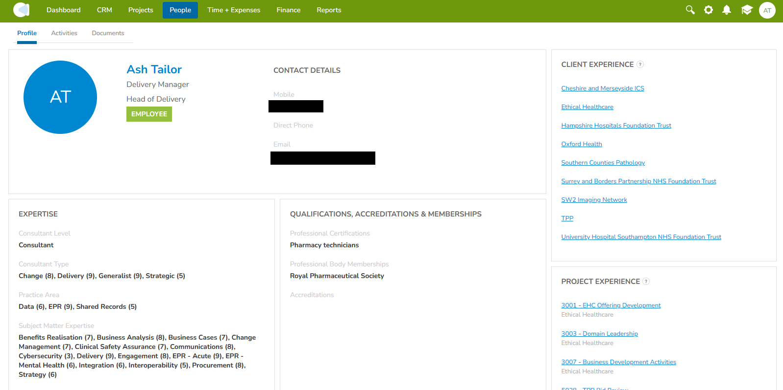

We have provided detailed information about our team members' expertise and skill sets within our Associate resource profiles. Please refer to **'*SD23 Example Associate Profiles*'**.